Ministry of Science and Education of Russian Federation

Peter the Great St.Petersburg Polytechnic University

—

Institute of Computer Science and Technology

**Department «Information security of computer systems»**

**LAB №1**

**Application object design**

course «OOP»

Student

Gr. 33508/3 Evgeniy G. Protsenko

<*signature*>

Instructor Andrey Y. Chernov

<*signature*>

Saint-Petersburg

2016

CONTENTS

1 Task 3

2 Introduction 4

2.1 Understanding application 4

2.1 Understanding UML 5

3 Result 7

3.1 Creation of application object design schema 7

3.2 Creation of application object design schema by using UML 7

4 Conclusion 8

References 9

Appendix A 10

Appendix B 11

# Task

Goal of this work is a creation of application object design schema.

For achieving necessary:

1. Select some complicated application;
2. Draw own view of application design by using 3 types of relation links:

* “is a” (generalization);
* “consist of” (composition);
* “has a” (aggregation).

Design schema must consist of at least 10 objects and all link types.

All links should be oriented.

1. Minimum requirements: the program should be more difficult than notepad or calculator
2. Describe each type of link by the example of selected application and drawn schema (why you choose this link);
3. Describe additional completed task (if it has been done).
4. Unusual model;
5. using UML;
6. using other link types;
7. software implementation of the schema of program (C#, C++)

# Introduction

## Understanding application

As a review unit I chose table game Munchkin. Munchkin is role-playing game. Main goal of the game is playing only to win by having the most powerful character.

Every player has board cards and cards in his hand. Board card are active and affect on some characteristics.

There are cards of two types: Door and Treasures. Treasure cards are Items that you can wear. Door cards are Classes, Races, Monsters and Curses.

In hand players may hold every type of cards, but on the board they may play only Items, Races, Classes cards.

Actually the main mechanic of the game is fights, so one or more players and one or more monsters involved in every fight.

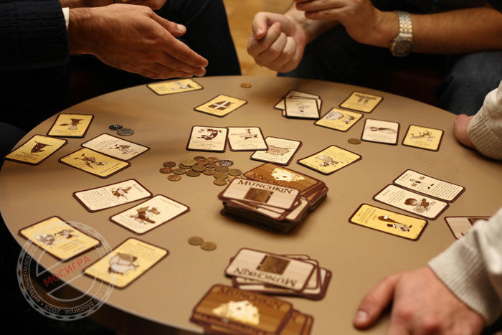

Figure 1 – Gameplay of Munchkin

## Understanding UML

The **Unified Modeling Language** (**UML**) is a general-purpose, developmental, modeling language in the field of software engineering, that is intended to provide a standard way to visualize the design of a system.

Relationships of classes in UML I used:

* A **generalization** (fig. 2) is a relationship between a general thing (called the superclass or parent) and a more specific kind of that thing (called the subclass or child). For example, Card is general name of specific cards like Curses, Items, etc…



Figure 2 – Generalization

* **Association**  is a relationship between classifiers which is used to show that instances of classifiers could be either linked to each other or combined logically or physically into some aggregation. For example, curses may cause on monsters and players stats.



Figure 3 – Directed association

* A **composition** (look at fig. 4) is a stronger form of aggregation in which the composite has sole responsibility for managing its parts— such as their allocation and deallocation. For example, the main components of the game are Players, Cards and Battles.



Figure 4 – Composition

* An **aggregation** (look at fig. 5) has the same idea like composition, but certain parts which are separated from the whole one, may exists independently. For example Items, which are not on the board are still Items, and may exist in differ context



Figure 5 – Aggregation

* A **dependency** (look at fig. 6) shows that realization of one class depends of other. For example, amount of cards that player may hold depends of the Class.



Figure 6 – Aggregation

# 

# Result

## Creation of application object design schema

For denoting a relation links in schema I used following graphical symbols:



Figure 7 – Link “has a”

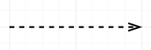

Figure 8 – Link “consist of”



Figure 9 – Link “is a”

Schema, which contains these relation links, is located in Appendix A.

## Creation of application object design schema by using UML

For creating UML diagram I used StarUML application. StarUML is an open source project to develop fast, flexible, extensible, featureful, and freely-available UML.

To UML representation, I also added Game class, which control game process.

UML diagram of Munchkin is placed to Appendix B.

F

F

F

F

F

F

F

F

# Conclusion

At this lab I created assumed models schema. Then I became acquainted with UML and idea of creating unified schema which doesn’t depend of programming language. So, I read some topics about UML[1] and created my own UML schema.

# References

1. [http://www.intuit.ru/studies/courses/1007/229/lecture/5956](http://www.intuit.ru/studies/courses/1007/229/lecture/5956?page=3)
2. <http://www.worldofmunchkin.com/rules/>

# Appendix A

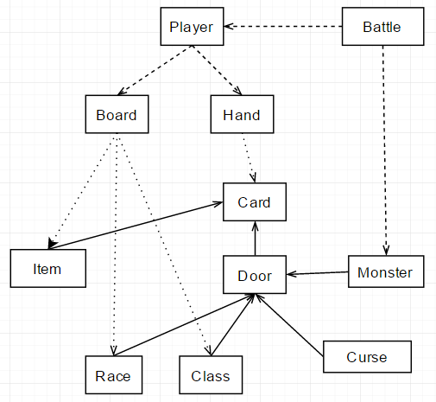

Figure 8 – Application object design schema

# Appendix B

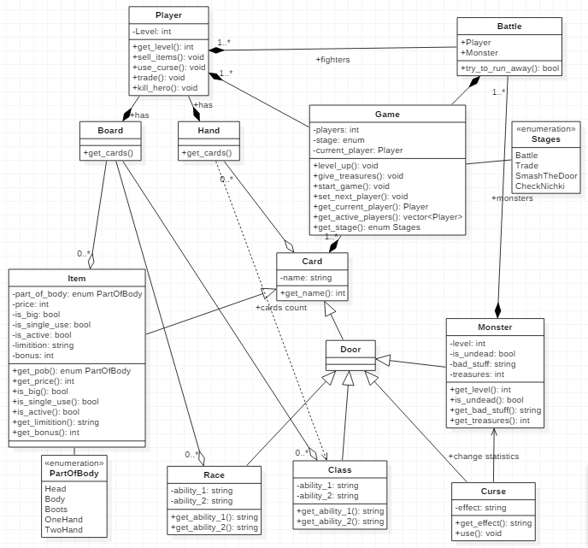

Figure 9 – Application object design schema, which was created by using UML